CHAPTER 1

INTRODUCTION

1.1 Basic overview
In the previous hardly any decades, noteworthy activities in the field of moving object recognition and following have been done to make following applications dependable, powerful and proficient: video observation, mechanical technology, verification framework, media creation, natural research and so on. Be that as it may, there are numerous difficulties which produce leaps in the improvement of these applications. These difficulties may incorporate light change, dynamic foundation, cover, impediment, shadow and so forth. The quantity of mishaps on the streets is because of the standard infringement. To stay away from such petty criminal offenses, traffic police must be accessible out and needs to constantly make sure if some vehicle is disregarding this standard.

A specific computerized arrangements were created to dispose of the violations; anyway every one of them had certain confinements. For instance, the video catching cameras wiped out need of a position to be available to check rule infringement. Be that as it may, entire put away video must be checked physically for the standard infringement situation. In the proposed framework, an answer for signal breaking infringement is given
.The framework incorporates a mechanized framework by utilizing IR sensor, camera and number plate acknowledgment application. In the framework IR sensor will be set close to zebra crossing line. In the event that any vehicle crosses the zebra line, the work area application will be started and will catch number plate picture. Number plate acknowledgment application by utilizing picture handling calculation will perceive number plate and SMS will be sent to the guilty party if there should arise an occurrence of rule infringement scenario. In almost all the nations they provide guidelines for driving which are accessible to all residents to drive cautiously.

Robotization in everyday life has picked up significance as of late. The quantity of mishaps on the streets is because of the standard infringement. A specific computerized arrangements were created to dispense with the infringement; anyway every one of them had certain impediments. For instance, the video catching cameras disposed of need of a power to be available to check rule infringement. Notwithstanding, entire put away video must be checked physically for the standard infringement scenario.[4] In this proposed framework, an answer for signal breaking infringement is given .The framework incorporates a robotized framework by utilizing IR sensor, camera and number plate
acknowledgment application.[3] In this framework IR sensor will be set close to zebra crossing line. In the event that any vehicle crosses the zebra line, the work area application will be started and will catch number plate picture. Number plate acknowledgment application by utilizing picture preparing calculation will perceive number plate and SMS will be sent to the guilty party if there should arise an occurrence of rule infringement scenario.[2].
Suspicious Human Activity Recognition from Video Surveillance is an active research area of image processing and computer vision which involves recognition of human activity and categorizes them into normal and abnormal activities. Abnormal activities are the unusual or suspicious activities rarely performed by the human at public places, such as left luggage forex plosive attacks, theft, running crowd, ﬁghts and attacks, vandalism and crossing borders. Normal activities are the usual activities performed by the human at public places, suchas running, boxing, jogging and walking, hand waving and clapping. Now-a-days, use ofvideo surveillance is increasing day by day to monitor the human activity which prevents thesuspicious activities of the human.An important chore of the video surveillance is to analyze the captured video framesfor identifying unusual or suspicious activities in security-sensitive region of any countrysuch as banks, parking lots, department stores, government buildings, prisons, military bases(Gouaillier and Fleurant 2009). Video Surveillance captures images of moving objects inorder to watch assault and fraud, comings and goings, prevent theft, as well as manage crowdmovements and incidents (Gouaillier and Fleurant 2009).

1.2 Objective

The objective of the proposed system is to provide a solution for signal-breaking violations by incorporating automation using IR sensors, cameras, and a number plate recognition application. The system aims to detect vehicles crossing zebra lines and automate the process of identifying violators.
An IR sensor is placed near the zebra crossing line. If any vehicle crosses the line, the desktop application is triggered, capturing the vehicle’s number plate image. Using image processing algorithms, the number plate is recognized, and an SMS notification is sent to the offender in case of a rule violation. This project aims to eliminate the need for manual inspection of stored video footage for violations.

The customary OCR based methodology for number plate acknowledgment doesn't work for the varieties in painting style of the number plates. In this paper creators have introduced a picture recovery based strategy to perceive the vehicle number plate caught utilizing an advanced cell to encourage the Car the board arrangement of a Smart office premise. In the proposed strategy an advanced mobile phone is utilized to catch the pictures and concentrate highlights of the vehicle number plate. These highlights are coordinated against predefined set of same vehicle number plate pictures in the database. The character pictures are coordinated in a proficient way to make it an ongoing arrangement.
The objective of this project is to develop an intelligent and fully autonomous video surveillance system capable of recognizing and categorizing human activities into normal and abnormal actions in real-time. The system aims to enhance public safety by detecting suspicious or dangerous activities, such as abandoned objects, theft, violence, explosive attacks, and other abnormal events in sensitive or crowded areas like airports, railway stations, shopping malls, and government buildings. By leveraging advanced image processing, computer vision, and machine learning techniques, the system can analyze video frames to identify unusual behaviors and generate timely alerts or alarms, enabling swift action by law enforcement or emergency services. This project seeks to overcome the limitations of traditional surveillance systems, such as the need for continuous human monitoring, by automating tasks like motion detection, activity tracking, classification, and abnormal event identification. Ultimately, it strives to provide a scalable, efficient, and reliable solution to ensure security and prevent incidents in high-risk environments.
4o

1.3 Scope of the project
This project addresses the limitations of existing OCR-based number plate recognition methods, which often fail due to variations in number plate styles. It proposes an image retrieval-based strategy for recognizing number plates. A mobile phone is used to capture the image, extract features, and match them with predefined images in the database.

As effectively expressed, the framework utilizing fiber optics characteristically has countless issues separated from the fundamental worries of significant expense and upkeep. Albeit an IR shade framework decreases the expense fundamentally, it is still very costly and less expensive choices are desired. As practically all the fee collection counters utilize cameras for security purposes, it was felt that the possibility of a framework utilizing IP cameras ought to be tried.

As for vehicle wellbeing, India meets just two out of the seven vehicle security measures by the World Health Organization (WHO). Bikes represent 25% of complete street crash passings. About 75%motorcycle riders engaged with mishaps kept on wearing protective caps, crash records appear. The primary driver of these fatalities is individuals riding bikes affected by liquor results and infringement of traffic rules which later on brings about genuine mishaps.

As adequately communicated, the structure using fiber optics normally has incalculable issues isolated from the guideline stresses of huge cost and backing. But an IR dazzle system diminishes the cost basically, it is still exorbitant and more affordable choices are desired. As for all intents and purposes all of the fee collection counters use cameras for security purposes, it was felt that the chance of a structure using IP cameras should be attempted.

The scope of this project encompasses the development of a robust, intelligent, and fully autonomous video surveillance system designed to enhance safety and security in various high-risk environments. The system aims to effectively monitor and analyze human activities in real-time, categorizing them as normal or abnormal based on predefined criteria. It will employ advanced image processing, computer vision, and machine learning techniques to detect suspicious activities such as theft, vandalism, abandoned objects, explosive attacks, and violent behavior in public and sensitive areas like airports, railway stations, shopping malls, banks, and government buildings. Beyond identifying abnormal activities, the system will automate critical tasks such as motion detection, activity tracking, classification, and real-time alert generation, significantly reducing reliance on human operators and overcoming the limitations of traditional surveillance systems. Furthermore, its applications extend to healthcare, such as fall detection for elder care, and emergency scenarios like fire detection. By integrating cutting-edge technology, the system will serve as a scalable and efficient solution to improve public safety, enhance security, and facilitate rapid response to potential threats or incidents.

Nowadays there are some financially accessible applications like Google Goggles that perceive pictures and content on the PDA, caught by the advanced cell's camera. Such applications face the accompanying impediments and difficulties like: (i) prerequisite of Internet Connection, (ii) necessity to separate individual characters on implanted versatile stage which have requirements as for both memory and processor, (iii) the nearness of specular reflection makes the acknowledgment task progressively troublesome, (iv) pictures caught are generally in the night, so the pictures could be obscured and have low difference (v) content Localization from the Background of the picture caught is a test. Then attempt to utilize a picture recovery based methodology for perceiving the number plate. One advanced mobile phone based ongoing picture recovery framework was proposed in [3]. In that work the creators have introduced a technique to consistently interface physical and computerized world utilizing paper records yet a similar strategy can't be sent in concern.

1.4 Organization of Report
The report is structured as follows:
- Basic Overview: A discussion on advancements in moving object recognition and tracking, along with challenges and implications for traffic rule violations and suspicious activity detection.
- Objective: A detailed explanation of the project’s goals, focusing on automating the detection of traffic violations ,suspicious activities and minimizing manual effort.
- Scope of Project: An exploration of the system’s components, including IR sensors, cameras, and image processing algorithms, as well as the challenges faced by existing solutions.
- Implementation Details: Insight into the use of IP cameras for cost-effective automation, along with an analysis of related technologies like Google Goggles.
- Challenges and Limitations: Discussion on issues like the need for internet connectivity, processing limitations, and difficulties in text localization due to low contrast and reflections in captured images.

CHAPTER 2

LITERATURE SURVEY

In the proposed work it revolves around control and robotization of canny road picture area structure for vehicles in average conditions. The objective is to scan for organizing information or a couple of data in the data pictures that are taken by the overhead mounted camera. The whole game plan by then channels the noise and various necessities to get a predictable movement of information for the vehicle to be guided normally. The frame work have used python for picture getting ready in addition, a microcontroller interfaced with it for genuine continuous taking care of and incitation of requests [1].

The purpose of this paper is to present an image affirmation programming mechanical assembly reliant on conventional estimation yet patched up in approach to get an OK answer and somewhat possibility of blemish. In like manner for supporting the item device a circumstance was proposed: vehicle ID reliant on label number (CILP). The item program was arranged in C++ using OpenCV library. The item contraption uses a custom philosophy of old style estimations to
achieve better results [2].

2.1 Background History

In the framework along with the economical development, traffic has extended enormously these days. As a result of the extending urban people and from this time forward the amount of vehicles, need of controlling the traffic in paths, turnpikes and boulevards is essential. Existing system a structure that separates the vehicle dynamically in street is done by using picture taking care of. The use joins computations used for continuous vehicle area, which relies upon establishment differencing and morphological exercises. Another image taking care of technique used is the edge acknowledgment methodology where the edges of the thing is recognized and various strategies for figuring traffic limits, for instance, checking the amount of vehicles, speed of the vehicles by applying an edge regard. The utilization of picture dealing with and PC vision techniques to the assessment of video progressions of traffic stream offers broad updates over the current methodologies for traffic data collection and road traffic watching. Other procedures experience the evil impacts of real inconveniences in that they are expensive to present and keep up and they can't perceive slow or fixed vehicles. Video sensors offer a reasonably low foundation cost with little traffic interference during upkeep. Most of the city traffic is compelled by sensors additionally, cameras will be presented in hugeexpressways and lanes. Such structures can allow expelling information from the more prominent traffic issue and urges us decide to improve the traffic methodology. The paper intends to render automate control system for traffic on streets and avenues. [3].

Human Action Recognition is an imperative research area in the field of computer vision due to its numerous applications such as person surveillance, human to object interaction, etc. Human Action Recognition is based on a pre-trained CNN model for feature extraction. Convolutional neural networks (CNN) is a technique of deep learning. Most convolutional neural networks used for recognition task are built using convolution and pooling layers followed by a few number of fully connected layers and identifying similar patterns in an interval to recognize the action by providing accuracy of 79-90% .

Nowadays the deluge of data is increasing with new technologies coming up daily. These advancements in recent times have also led to an increased growth in fields like Robotics and Internet of Things (IoT). This paper helps us draw a comparison between the usage and accuracy of different Human Activity Recognition models. There will be discussion on mainly two models- 2-D Convolutional Neural Network and Long-Short term Memory. In order to maintain the consistency and credibility of the survey, both models are trained using the same dataset containing information collected using wearable sensors which was acquired from a public website.

In the proposed work, the point is to construct the utility of road transportation structures by diminishing traffic blockage to support the two individuals and society all things considered. To accomplish the inspiration, the paper propose an essential course bearing instrument subject to mass customer support. Through multiagent amusement, investigate the limit of the proposed instrument for improving traffic capability of both individual drivers and whole systems. The propagation results that i) the proposed part improves capability for the drivers who use it and the entire transportation structure, and
ii) the social problems in course choice practices occur in a winding and ring framework [5].

The investigation trademark properties of the obstructed traffic states on a 40 km broadened length of the German interstate A7 north of Frankfurt/Main. Among the about 250 breakdowns of traffic stream in 175 days, that have perceived five different kinds of spatio-transient stop up structures and their blends. Taking into account a "flexible smoothing procedure" for the portrayal of locator data, then in like manner inspect explicit features of breakdowns such as the "boomerang sway" which means that legitimately problematic traffic stream. Questionable issues, for instance, "synchronized stream" or eccentric waves are tended to likewise. Finally, the exploratory results are differentiated and phenomenal speculative thoughts and understandings of blockage plans, explicitly first-and second-demand detectable traffic models [6].

The paper proposes another adaptable establishment extraction and invigorating estimation for vehicle area and following. Dull level estimation and two tightening loads

are familiar with decline the impact of condition lighting condition in establishment extraction system, two discriminant limits are used to perceive counterfeit moving things and certified moving articles for dealing with the stop issue of establishment reviving. The test outcomes show that the proposed procedure is progressively healthy, exact and notable than standard methods, and is anything but difficult to complete and sensible for consistent vehicle area and following [7].

Traffic thickness transforms into a huge issue in present day urban zones due to proceeded with advancement in masses, better desires for living, and extended degrees of flexibility. Likewise, natural tainting is on the climb, normal resource spares are being depleted, and drive times are extended. These conditions are growing the necessity for convincing organization of traffic stream. Improved traffic stream the block remembers saving estimations for transportation establishments, and following thickness levels so overhauls can be executed. Existing procedures for party these bits of knowledge are extreme, work genuine, and require remote, detached data acquiring. In order to address these issues, the present a Smart Vehicle Detection System (SVEDECS) that gives consistent bits of knowledge of traffic stream, prepared for following vehicle speed and vehicle type. The paper portray an utilization of SVEDECS contained remote appealing sensor centers and a section center point [8].

Body activity recognition using wearable sensor technology has drawn more and more attentions over the past few decades. The complexity and variety of body activities makes it difficult to fast, accurately and automatically recognize body activities. To solve this problem, this paper formulates body activity recognition problem as a classification problem using data collected by wearable sensors. And three different machine learning algorithms, support vector machine, hidden markov model and artificial neural network are presented to recognize different body activities. Various numerical experiments on a realworld wearable sensors dataset are designed to verify the effectiveness of these classification algorithms.
police mannequin. Outcomes of a precise field evaluation show that the structure performs well in an arrangement of veritable rush hour gridlock scenes [11].

In the work, advise a novel designing for making Intelligent Traffic Control Systems (ITCS). The vehicle works in two modes generally Normal mode and Emergency mode. The sign which will be given on the indication review will be appeared on the vehicle itself for driver's advantage. Here Image dealing with system is used to distinguish the traffic thickness of every road in the convergence and release the strongly thick road once in a while. The vehicle is given modified easing back system if there ought to be an event of blocks coming in the way from which the mischief caused to the individual by walking, driver and vehicle will be evaded. The Traffic police is supported with the sign system at if traffic rules are broken. GPS/GSM developments are used in the undertaking which gives information about road disasters and in case the vehicle is taken. The adequacy of the proposed structure lies in the manner that the existing system works traffic signals subject to the current condition of vehicular volume in different methods of a road crossing and not on pre-given out events [12].

The way people look in terms of facial attributes (ethnicity, hair color, facial hair, etc.) and the clothes or accessories they wear (sunglasses, hat, hoodies, etc.) is highly dependent on geo-location and weather condition, respectively. This work explores, for the first time, the use of this contextual information, as people with wearable cameras walk across different neighborhoods of a city, in order to learn a rich feature representation for facial attribute classification, without the costly manual annotation required by previous methods. By tracking the faces of casual walkers on more than 40 hours of egocentric video, we are able to cover tens of thousands of different identities and automatically. Finally, machine learning methods are used to classify the extracted feature vector. Meanwhile, this study uses t- distributed Stochastic Neighbor Embedding (T-SNE) to visualize the face recognition feature vectors to verify the effectiveness of the face recognition feature vectors on the issue of gender classification. The proposed method has achieved a recognition rate of 99.2% and 98.7% on the FEI dataset and the SCIEN dataset, respectively. Besides, it also achieves a recognition rate of 97.4% on the Asian star face dataset, outperforming existing methods, which shows that the proposed method is helpful for the research of facial gender.

The paper presents a suitable traffic surveillance system for recognizing and following moving vehicles in night time traffic scenes. Starting, a speedy splendid thing division process reliant on customized stunned histogram thresholding is applied to suitably isolate mind blowing objects of interest. This modified stunned thresholding approach gives a generous and flexible recognizable proof structure that functions admirably under various night light conditions. The expelled splendid articles are then taken care of by a spatial gathering and following procedure that finds and analyzes the spatial and short lived features of vehicle light models, and recognizes and arranges moving vehicles and motorbikes in busy time gridlock scenes. The proposed constant vision structure has moreover been realized and surveyed on a TI DM642 DSP-based embedded stage. The system is set up on raised stages to perform traffic perception on real interstates and urban avenues. Exploratory results show that the proposed traffic surveillance approach is achievable and reasonable for vehicle acknowledgment and conspicuous verification in various night time circumstances [15].

surveillancevideo systems are gaining increasingattention in the field of computer vision due to its demands of users for the seek of security. It is promising to observe the human movement and predict such kind of sense of movements. The need arises to develop a surveillance system that capable to overcome the shortcoming of depending on the human resource to stay monitoring, observing the normal and suspect event all the time without any absent mind and to facilitate the control of huge surveillance system network. In this paper, an intelligent human activity system recognition is developed. Series of digital image processing techniques were used in each stage of the proposed system, such as background subtraction, binarization, and morphological operation. A robust neural network was built based on the human activities features database, which was extracted from the frame sequences. Multi-layer feed forward perceptron network used to classify the activities model in the dataset. The classification results show a high performance in all of the stages of training, testing and validation. Finally, these results lead to achieving a promising performance in the activity recognition rate.

2.2 Problem statement
Traffic violations and suspicious activities have become a significant challenge in urban areas, leading to accidents, congestion, and potential security threats. Manual enforcement of traffic rules is often ineffective due to limited human resources, delayed response times, and an inability to address violations consistently. In addition, current systems lack integrated functionality to detect suspicious activities, notify emergency services about accidents in real-time, and maintain comprehensive road safety. There is a critical need for an automated system that can detect traffic violations, accidents, and suspicious behaviors while ensuring timely interventions and notifications to relevant authorities
The Technology frequently development makes various individuals utilize the advancement for doing everything. Utilized for achieving something incredible, anyway there are various individuals use it for doing criminal, for instance, burglarizing. Of course, there is something found for preventing that issue. It is a gadget for perceiving face. Face affirmation is made for recognizing a face by cutting edge picture. This paper presents an investigation on security of a room. The room must be opened by recognizing commercial planning the quintessence of the one that has been inputted to the data base of the structure. Utilized for achieving something incredible, anyway there are various individuals use it for doing criminal, for instance, burglarizing. Of course, there is something found for preventing that issue. It is a gadget for perceiving face. Face affirmation is made for recognizing a face by cutting edge picture. Haar course classifier is used in this investigation. The strategies of recognizing of the articles were discussed in the existing system. From the preliminary test, it might be surmised that the proposed procedure is amazing enough in setting up the features of the articles [17].

Thing revelation subject to the significant learning has achieved fantastic displays. Regardless, there are various issues with pictures in authentic shooting, for instance, uproar, darkening and turning jitter, etc. These issues critically influence object distinguishing proof. Using traffic finishes paperwork for example, developed picture defilement models which rely upon YOLO orchestrate and joined traditional picture getting ready procedures to reproduce the issues existing in certified shooting. In the wake of setting up the assorted degradation models, took a gander at the effects of different debasement models on object recognizable proof. The existing system used the YOLO framework to set up an overwhelming model to improve the ordinary precision (AP) of traffic signs acknowledgment in real scenes [18].

For activity-based analysis, activity detection is a critical component of video surveillance systems. Traditionally, human operators evaluated the video stream from CCTV cameras. These operators keep an eye on numerous displays at once, looking for unusual activity. This is a tedious and ineffective method of monitoring. Because humans are likely to make mistakes, this method is inefficient. Multiple screens cannot be monitored by a human operator at the same time. As a result, obtaining timely and reliable activity data becomes extremely challenging. This is why we require an automated method, and the suspicious activity detection system has provided us with the ideal option. Suspicious activity detection systems based on video can either replace or assist human operators in monitoring odd behavior. They get a quick and precise answer from the system

2.3 Existing System

Existing traffic management and violation detection systems are predominantly manual or semi-automated. Traditional methods rely heavily on traffic police for monitoring and enforcement, which can lead to inconsistencies and human error. While some cities employ surveillance cameras to monitor traffic, these systems are often limited to recording footage, leaving the detection of violations to manual review. Additionally, there is no direct integration with number plate recognition systems to automatically issue fines. Furthermore, the detection of accidents or suspicious activities often relies on eyewitnesses or delayed reporting, resulting in slower emergency response times.

- Embedded System
- Traffic detection system using Android
- RFID Technology is used for Vehicles to control speed limit
- VechiTrack

Outline of existing framework:
A superior fiber optic sensors are utilized for discovery of moving vehicles. A normal establishment comprises of an interface gadget with transmitter (LED), recipient (photograph identifier), and light guide association link (feeder) and FOS. As the vehicle disregards the sensors there is an adjustment in the sign levels acquired from the sensors. The yield signals from the FOS are taken care of into a sign handling and information assessment unit which contains the calculation, which processes pivot check, hub dividing, vehicle lengths and vehicle classes dependent on schedule, separation recipe, and measure of smaller scale bowing.

An IR dazzle basically includes an transmitter and gatherer. These window decorations make an away from of the vehicle as it experiences it. In any case the entire profile of the vehicle can't be procured by using just one bit of IR daze in light of changing pace of the vehicle that passes the portal. Thusly it is basic to know the speed of the vehicle. Using the detachment between the window adornments and the time, find out the speed of the vehicle. With the speed of the vehicle known and the repeat of pulses acknowledged ,can choose the correct profile of the vehicle.

Postponements and traffic bottlenecks speak to a huge monetary misfortune and badly designed problems during transportation of people and merchandise. That is, transportation frameworks despite everything have a large range of problem that should be tended to. The Intelligent Transportation Systems (ITS) are relied upon to give an effective and current approach to manage these problem. In any case, hidden advancements are usually not reachable for urban settlements with spending restriction, for example, in provincial territories and in creating nations. The presents a novel and reasonable design expecting to improve vehicular traffic the board dependent on smart Virtual Police Agents (VPA). This design is enlivened from genuine police specialists

figure which are situated to oversee traffic problems productively. The copying of fundamental highlights of the police operator job in VPA brings about community and progressive specialist based relationship engineering. This structure expects to build up framework ideal situated in rush hour gridlock stream balance with most extreme stream and least expense.
2.4 Issues and Challenges of Existing System

Limitations of Existing Systems
The current frameworks endured numerous issues like just the traffic status specifically region and following just vehicles which has RFID labels.
- Existing traffic management and violation detection systems are predominantly manual or semi-automated. Traditional methods rely heavily on traffic police for monitoring and enforcement, which can lead to inconsistencies and human error. While some cities employ surveillance cameras to monitor traffic, these systems are often limited to recording footage, leaving the detection of violations to manual review. Additionally, there is no direct integration with number plate recognition systems to automatically issue fines. Furthermore, the detection of accidents or suspicious activities often relies on eyewitnesses or delayed reporting, resulting in slower emergency response times.
- The primary drawbacks of the existing systems are:
- Manual Monitoring: The reliance on human effort for traffic monitoring is inefficient and prone to errors.
- Limited Automation: Current systems do not automatically detect traffic violations or accidents in real-time, leading to delayed actions.
- Lack of Integration: There is no seamless integration between violation detection, number plate recognition, and fine generation.
- Poor Emergency Response: Accident detection is often slow, delaying notifications to hospitals or emergency services.
- Absence of Suspicious Activity Monitoring: Current systems focus solely on traffic management without addressing potential security threats from suspicious activities around the traffic environment.

2.5 Proposed System
The proposed system is an AI-driven, automated traffic violation and suspicious activity recognition solution designed to overcome the limitations of existing systems. It incorporates image processing, machine learning, and Optical Character Recognition (OCR) technologies to detect violations such as signal jumping, no parking, triple riding, and riding without helmets in real time. Upon detecting a violation, the system uses number plate recognition to identify the vehicle and automatically generate a fine for the responsible user.
In addition to traffic violations, the system is equipped with accident detection capabilities. It monitors road conditions, identifies accidents, and instantly notifies nearby hospitals and emergency services to ensure swift medical intervention. The system also extends its functionality to detect suspicious activities in the vicinity of traffic areas. Using behavioral analysis and pattern recognition, it identifies potential security risks, such as unusual gatherings or tampering with vehicles, and informs the police for immediate investigation

Advantage of Proposed System

    - The System is used to detect and read number plates automatically 24/7 in real time
    - Installed model will help travelers to obey traffic rules
    - Can operate simultaneously in multiple lanes
    - Model detects and recognizes different dimensions, contrast , colors number plates with variety of character font and style.

Scope
Tag acknowledgment methods utilized for vehicle distinguishing proof purposes. The sole expectation of this venture to locate the most effective approach to perceive the enrolment data from the computerized picture which is obtained from the camera. This procedure has some rules which includes three stages. Initial step is the label control, paying little regard to the label size and bearing. The resulting advance is the division of the characters and last development is the affirmation of the characters from the tag.

The task reveals the central thought of different estimations are necessary to achieve the characters insistence from the tag during Template Matching. Where this framework can likewise be utilized in exceptionally populated territories and profoundly confined zones to effortlessly distinguish traffic rule damaged vehicles and proprietor's name, address and other data can be recovered utilizing this framework. This framework can be robotized and it is utilized to perceive vehicles without approval, vehicles that damaged guidelines at populated territories like shopping centres, colleges, emergency clinics and other vehicle parking areas. This can likewise be utilized on account of vehicle use in psychological oppressor activates, carrying, invalid number plates, taken vehicles and other criminal operations.

In light of this wearing cap is obligatory according to traffic rules, infringement of which draw in powerful fines. In spite, an enormous number of motorcyclists don't comply with the standard. By and by, every significant city previously sent enormous video reconnaissance system to keep a vigil on a wide assortment of dangers. In this way utilizing such previously existing framework will be a cost productive arrangement, anyway these frameworks include an enormous number of people whose exhibition isn't reasonable for significant stretches of time. Ongoing examinations have indicated that human reconnaissance demonstrates incapable, as the length of checking of recordings expands, the blunders made by people likewise increments.

The component of the calculation referenced above aided in accomplishing quicker character acknowledgment of the tag. This procedure of character acknowledgment comprises of steps like Image handling, Defragmentation, Resizing and Character restriction that are required to be performed on the picture all together for Template Matching to be finished.

Bike is a predominant technique for transportation in essentially every country. In any case, there is a high peril included because of less confirmation. To reduce the included

danger, it is particularly charming for bike riders to use head defender. Viewing the support of head defender, Governments have made it an at fault offense to ride a bike without top and have gotten manual frameworks to get the violators. In this model edges are isolated from the chronicles and changed over to gray scale picture, using format planning methodology (cross association assessment) bike riders are distinguished in the packaging.

Objectives of the Proposed Work
The primary objectives of the Traffic Violation and Suspicious Activity Recognition Project are:

- Automate Traffic Violation Detection: To develop an AI-powered system capable of detecting common traffic violations such as signal jumping, no parking, triple riding, and riding without helmets in real-time.
- Number Plate Recognition and Fine Generation: To implement Optical Character Recognition (OCR) technology for capturing and recognizing vehicle number plates of offenders, followed by automated fine generation and notification to the responsible individuals.
- Accident Detection and Emergency Response: To create a system that identifies accidents on roads and promptly informs nearby hospitals or emergency stations to ensure swift medical assistance.
- Suspicious Activity Monitoring: To integrate surveillance features that detect suspicious behaviors, such as unauthorized access or criminal activities near traffic zones, and notify law enforcement agencies for timely intervention.
- Enhance Road Safety and Public Security: To reduce traffic violations and accidents, improve emergency response times, and ensure public safety through continuous monitoring of both traffic and surrounding areas for suspicious activities

CHAPTER 3

System REQUIREMENT

3.1 HARDWAREREQUIREMENTS

HARDWARE

System : intel i3/i5 2.4 GHz.

Hard Disk : 500 GB

Ram : 4/8 GB

Functional Requirement
    - System should get the number plate of the vehicle
    - System should refresh the violation report to framework.
    - System ought to naturally identify the number plate of vehicle
    - System should naturally sending the update message to the proprietor of the vehicle ofthe infringement

Non Functional Requirement

Usability:
- Easy Interface for catch of picture and Updated in the cloud

Dependability:
- Capture the low light effectively.
- Violation Filing.

Execution:
- Should not take unnecessary time in handling the caught picture and preparing it.

Supportability:
- Contain straightforward code with arrangements for future improvement.

3.2 Software Requirements
- Open CV
- Python

CHAPTER 4

SYSTEM DESIGN

4.1 System Architecture

Detect Helmet
Detect Signal Jump

Camera for capturing image

Send SMS

Detect Number pl

Detect
No Parking

PC
with Open CV

Figure 5.1: System Architecture of virtual traffic police

Detect Triple riding
Systems design is the process of defining the architecture, modules, interfaces and data for a system to satisfy specified requirements. Systems design could be seen as the application of systems theory to product development. There is some overlap with the disciplines of systems analysis, systems architecture and systems engineering. If the broader topic of product development "blends the perspective of marketing, design, and manufacturing into a single approach to product development,” then design is the act of taking the marketing information and creating the design of the product to be manufactured.
Systems design is therefore the process of defining and developing systems to satisfy specified requirements of the user.Until the 1990s, systems design had a crucial and respected role in the data processing industry. In the 1990s, standardization of hardware and software resulted in the ability to build modular systems. The increasing importance of software running on generic platforms has enhanced the discipline of software engineering. Objectoriented analysis and design methods are becoming the most widely used methods for computer systems design. The UML has become the standard language in object-oriented analysis and design
It is widely used for modeling software systems and is increasingly used for high designing non-software systems and organizations. It is a process of planning a new business system or replacing an existing system by defining its components or modules to satisfy the specific requirements. Before planning, you need to understand the old system thoroughly and determine how computers can best be used in order to operate efficiently. System Design focuses on how to accomplish the objective of the system.
The System Design Document is a required document for every project. It should include a high level description of why the System Design Document has been created, provide what the new system is intended for or is intended to replace and contain detailed descriptions of the architecture and system components of the system. Based on the user requirements and the detailed analysis of the existing system, the new system must be designed. This is the phase of system designing. It is the most crucial phase in the developments of a system. The logical system design arrived at as a result of systems analysis is converted into physical design.

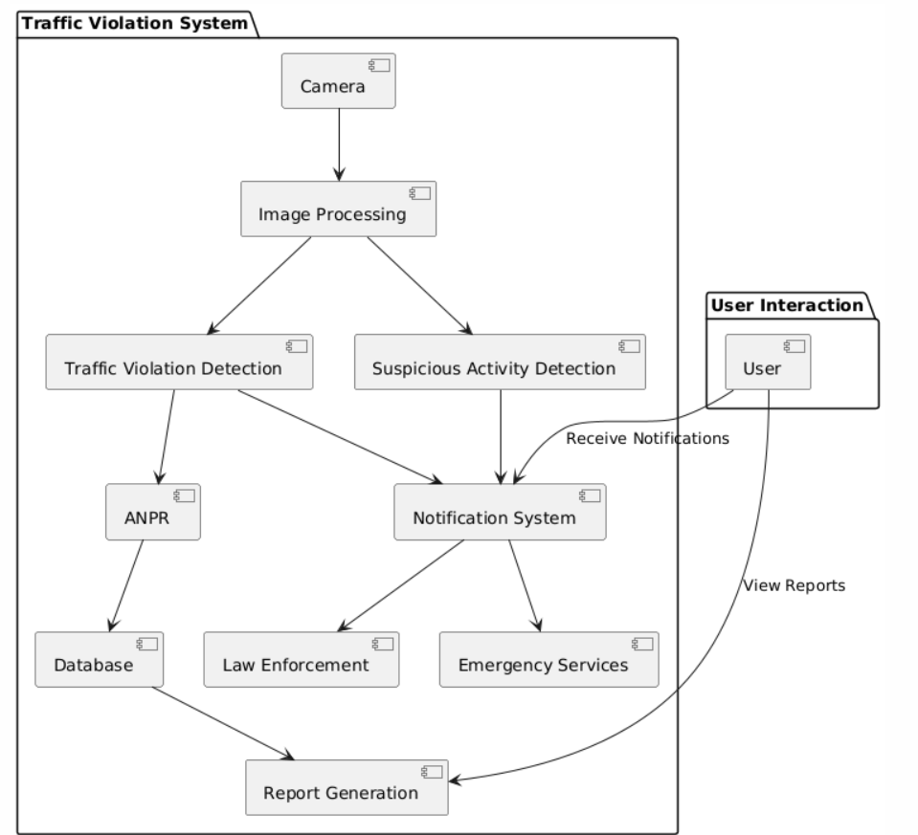

The proposed framework figure 5.1 will get the picture of the vehicles voyaging and minds the slim chance that any vehicle hurt the traffic rules, in the event that point of fact, by then the raspberry pi module will take starting and recognize the number plate of specific vehicle.

Modified number-plate affirmation can be used to store the photos got by the cameras similarly as the substance from the tag, with some configurable to store a photograph of the driver. ANPR advancement must consider plate arrangements here and there.Concerns about these systems have concentrated on security issues, for instance, government following inhabitants' turns of events, misidentification, high mix-up rates, and extended government spending. Intellectuals have depicted it as a kind of mass perception.

ANPR utilizesa optical character recognition (OCR) on imagecaptured by cameras. Right when Dutch vehicle selection plates transformed to a substitute style in 2003, one among the developments made was to the substance fashion, presenting small holes in explicit writing, (for example, X and Y) to formulate them continuously evident and
along these lines sensibly reasonable to such structures. Some mark strategies use collections in content estimations and orchestrating—ANPR structures must have the decision to change in accordance with such contrasts so as to be truly stunning. Sensibly tangled frameworks can change in accordance with overall assortments, at any rate different endeavors are just custom fitted to every nation.

The cameras used can be existing road rule usage or shut circuit TV cameras, similarly as compact units, which are ordinarily associated with vehicles. A couple of systems use infrared cameras to take an all the more away from of the plates.

Structure configuration is a material model that portrays the system's structure and conduct. This incorporates the casing pieces and the relationship clarifying how they cooperate to alter the general structure.

Framework design is the strategy for describing a structure's engineering, parts, segments, interfaces, and data to satisfy the predefined preconditions. Design of systems could be deciphered as utilizing the hypothesis of structures to propel objects. The examination and procedures arranged in Article form into the most generally utilized strategies for the structure of PC systems. Along these lines, the arrangement of structures is the best approach to portray and assemble systems to meet the customer's characterized needs. The UML has become the standard language in object arranged examination and structure

Camera Positioning by the CCTV association in UK figure 5.2 where the camera is arranged other than really in the line of the advancing toward vehicle the ANPR provider must be advised. Various systems won't work with more than logically 1 or 2 degrees of level inclination or vertical insurgency. The arranging of the camera is a most critical idea for good action of an ANPR structure. This can change the degree of affirmations to number of vehicles from 20% or 30% to approach on 100%.

The examination and procedures arranged in Article form into the most generally utilized strategies for the structure of PC systems. Along these lines, the arrangement of structures is the best approach to portray and assemble systems to meet the customer's characterized needs.

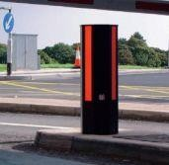

Figure 5.2: Camera placed by the CCTV company in UK

Single camera covering an obstacle entrance: Presumably the best position is for a camera and illuminator in a 2M high bollard seeing clearly at the advancing toward vehicle.

Single camera covering one way: This could be a post mounted unit about from 20M to 40M from the vehicle.

Single or various cameras covering different ways: This is an outstanding application requiring commitment from the ANPR provider. Town center cameras recently presented: Usually the cameras won't have been presented considering ANPR in this manner the arranging won't be upgraded, they will generally be concealing with no infrared illumination and will working with the screen speed set to 2/50th. The central thing to address is the shade speed if it is portable. The best would be if the speed can be set remotely, if only one out of every odd camera ought to be visited and the speed set truly. The perfect setting is to 2/1000th. Elective settings may be 2/250th for traffic up to 6 MPH and 2/500th for traffic up to 50 MPH. Note that all of these settings will impact the low-light limit of the cameras and an exchange off may be required.

Cameras on motorway spans: Again an exceptional application requiring contribution from the supplier.

Clog charging cameras: This application requires contribution from the ANPR supplier and nearby authority before beginning to think about a particular.

Cameras in Police vehicles: These are typically shading cameras mounted on a turn mount and can see pictures to the front or either side of the vehicle. This is another unique application requiring contribution from the supplier.

Overview cameras:

It is regularly important to have an ordinary shading picture of the vehicle particularly where indictment or clog charging is the application. This would be a different shading camera mounted nearby or just underneath the ANPR camera. Figure 5.2 sparing the outline picture is activated by the ANPR camera enlisting a number plate. This at that point adds a shading picture to a similar record for future reference. It is commonly a bogus economy to endeavor to join the number plate acknowledgment and review utilizing a solitary camera for every minute of every day activity.
Steps followed:
- Extraction of the Number Plate.
- Detection of HELMENT & Triple Riding
- Detection of over speeding.
- Character Segmentation.
- Template Matching.

OCR (optical character confirmation) is the utilization of headway to see printed or deciphered substance characters inside computerized pictures of physical archives, for example, a filtered paper report. The essential arrangement of OCR consolidates looking at the substance of a record and causing an interpretation of the characters into code that to can be utilized for information arranging. OCR is from time to time in like way proposed as substance insistence.

OCR systems are contained a blend of hardware and programming that is used to change over physical documents into machine-clear substance. Gear, for instance, an optical scanner or specific circuit board is used to copy or read content while programming customarily handles the impelled getting ready. Programming can in like manner misuse man-made cognizance (AI) to complete additionally created procedures for sharp character affirmation (ICR), like distinctive tongues or styles of handwriting.The procedure of OCR is most normally used to transform printed copy legitimate or notable reports into PDFs. When put in this delicate duplicate, clients can alter, configuration and search the archive as though it was made with a word processor.

The initial step of OCR is utilizing a scanner to process the physical type of a report. When all pages are replicated, OCR programming changes over the archive into a two- shading, or high contrast, adaptation. The filtered in picture or bitmap is broke down for

light and dim territories, where the dull regions are distinguished as characters that should be perceived and light zones are recognized as foundation.

The dim regions are then prepared further to discover alphabetic letters or numeric digits. OCR projects can shift in their procedures, yet ordinarily include focusing on single character, word or square of content at once. Characters are then recognized utilizing one of two algorithms: Pattern acknowledgment OCR programs are taken care of instances of content in different text styles and organizations which are then used to think about, and perceive, characters in the examined report.

Highlight discovery OCR programs apply rules with respect to the highlights of a particular letter or number to perceive characters in the checked report. Highlights could incorporate the quantity of calculated lines, crossed lines or bends in a character for correlation. For instance, the capital letter "A" might be put away as two slanting lines that meet with a level line over the center.

At the point when a character is distinguished, it is changed over into an ASCII code that can be utilized by PC frameworks to deal with further controls. Clients should address fundamental blunders, edit and ensure complex formats were dealt with appropriately before sparing the report for sometime later.

Optical character acknowledgment use cases

OCR can be used for a variety of applications, including:
Scanning printed records into forms that can be altered with word processors, as Microsoft Word or Google Docs.
  - Ordering print material for web files.
  - Mechanizing data area, extraction and dealing with.
  - Deciphering records into content that can be scrutinized resoundingly to apparently blocked or surprise customers.
  - Archiving notable data, for example, papers, magazines or phonebooks, into accessible configurations.
  - Electronically keeping checks without the requirement for a bank employee.
  - Placing significant, marked authoritative archives into an electronic database.
  - Recognizing content, for example, tags, with a camera or programming.
  - Sorting letters for mail conveyance.
  - Translating words inside a picture into a predetermined language.

  - Benefits of optical character acknowledgment

The principle focal points of OCR innovation are spared time, diminished mistakes and limited exertion. It likewise empowers activities that are not proficient with physical duplicates, for example, packing into ZIP documents, featuring catchphrases, fusing into a site and connecting to an email.
4.2 Context Analysis Diagram

4.2.1 Class Diagram
The Figure 5.3 shows the class diagram in which there are five classes they are are camera ,image identifier ,helmet ,database ,valid vehicle.
Helmet
Image_No
Get_image 0 Detect_violator

Camera
Camera _id Image_No
Get-image 0
Send_image 0

Image Identifier
Image_No
Get_No 0
Send_No 0

Figure 5.3: Class Diagram
Database
Record_ No Vechile_No
Driver
Get_No Store 0

Valid Vehicle
Intimation
Get-No 0 Valid/Invalid

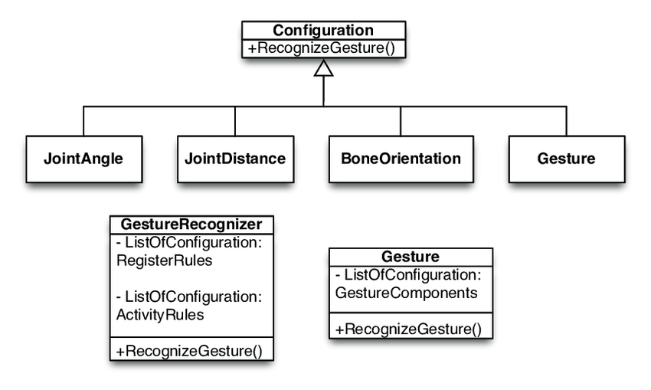

Flow Chart

Start
Initialize the camera
If any traffic rule violation happens?
YES
NO
Stop
Fetch details of owner and send message
Recognize the number plate
Capture the image of number plate
Monitoring the camera

Figure 6.1: Process flow chart

A procedure of flow chart clarifies how precisely the virtual traffic police model works. Once in the wake of turning on the camera it begins working so that on the off chance that any vehicle violates any of the traffic rules, at that point the camera catches the picture of that specific vehicle and tells about the rule violation that have been made and sends message to owners. This is the means by which the fig 6.1 works.

4.2.2 Data Flow Diagram
DFD of Level 0:
The data stream chart is a schematic graph of the "way" of the information framework, indicating the points of the procedure. A DFD is utilized consistently as an initial step to

make a system layout without expansive clarification, which can be clarified later. DFDs can likewise be utilized to mirror the treatment of information.


Input image
License plate
Character segmentation
Optical character
Output (text)

Figure 6.2: Dataflow Level 0 outline
The Figure 6.2 Dataflow Level 0 outline shows the reflect of treatment of information. DFD of Level 1:

Camera

Violation detection

Violation detection

Fine with intimation

Extract number plate

Helmet, triple riding and signal jump

Process image
Object detection like helmet and number of persons

Detect and recognize number plate

Display data
Vehicle records
Vehicle records

Update fine

Intimate about violation
System

Figure 6.3: DFD level 1 outline

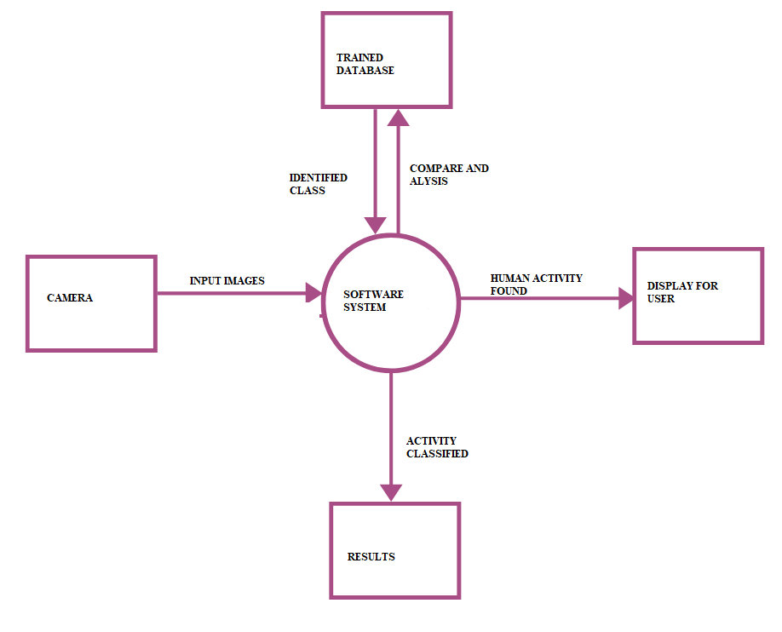
The Figure 6.3 Dataflow Level1 outline shows the putting away of information in the database. That means how exactly extracted information will be saved in the database which clearly explained in the level 1of DFD.

Object OrientedDesign

During the sorted-out stage, the perspective on the application made during the raised level course of action is segregated into modules and assignments. Defense configuration is developed for each program and sometime later recorded as program focal points. For each program, a unit test plan is made.

Activity Diagram
Input image
Pre-processing
Offense Detection
Number Plate Detection
Intimation
Figure 6.4: Activity Diagram of virtual traffic police

The Figure 6.4 shows the action happen in scheme that means once after giving the input image to PC that will undergo for the preprocessing steps once after completing thepreprocessing steps that will detect the rule violated, if any of traffic rule is violated then the number plate will be recognized and fetch the details of owner of the respective vehicle and send text message .
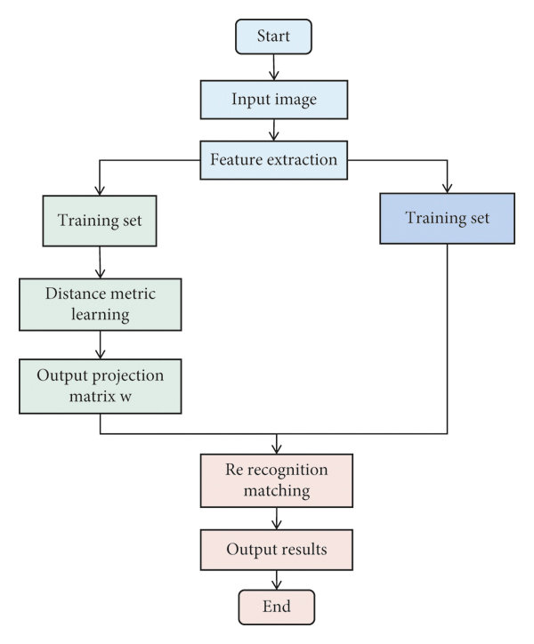
.

4.2.3 Sequence Diagram
Input image
Pre-processing
dilation
erosion
median filtering
Number plate extraction
Histogram analysis Adaptive thresholding
Image subtraction

matching
Character segmentation
Find contour Store valid contour
Check position of contour
Template matching Store result
Show result
Done/exit
Number plate
Pre- processing
Pre-processing image
Contour
Contour
Software

Software
User
User
Image
Number plate
Image
Figure 6.5: Sequence Diagram
The Figure 6.5 shows the sequence of method happen in the modules, as the user gives the input as a image it will do the preprocessing of image to reduce the noise and then all other preprocessing steps then recognize the number plate and do the character recognition and then extract the exact number form the captured image.

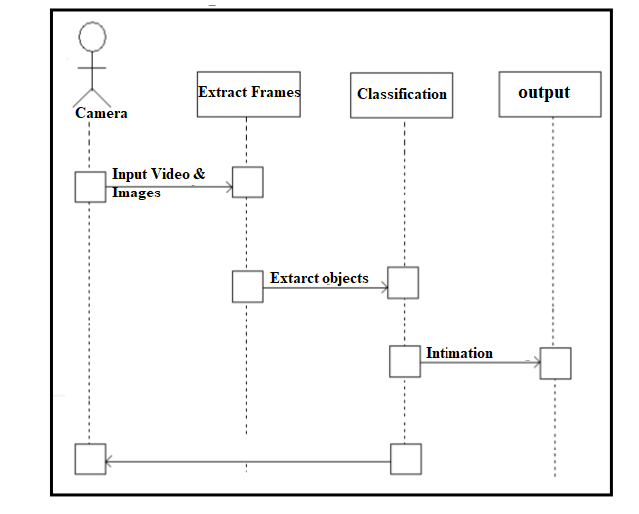

4.2.4 Use Case Diagram
The utilization case definition at its least difficult is a representation of the customer's relationship with the application that exhibits the customer's connection to the unmistakable use cases that incorporate the customer. A case chart of utilization distinguishes the different sorts of clients of a procedure and the particular instances of utilization and is frequently trailed by various kinds of diagrams too. While a use case itself may drill into a lot of understanding concerning every likelihood, a use case diagram can help give an increasingly noteworthy level point of view on the system. It has been said before that "Use case charts are the designs for your system". They give the improved and graphical depiction of what the system should do.

Use case diagram 1:
Vehicle
Owner of vehicle
Capture image
Digital camera
Register
Database
Image pre- processing
Detect violation and find number plate region
Recognition
Segmentatio n
Plate extraction

Figure 6.6: Use case diagram 1

The Figure 6.6 shows the use case diagram in which camera will catch the picture and picture handling step occur in this chart. Use case diagram 1 is only for giving input, image processing and for the detection of rule violation.

Use case diagram 2:
Input image
Median filtering
Pre- processing
erosion
Detect violation and number plate extraction
dilation
Character segmentatin
Edge detection
Template matching
Histogram analysis
Detecting contours
Done
Display number

Figure 6.7: Use case diagram 2

The Figure 6.7 shows the use case diagram in which camera will catch the picture and afterward picture preparing steps occur. Use case 2 tells us about the number plate recognition, and sending message to the owners.

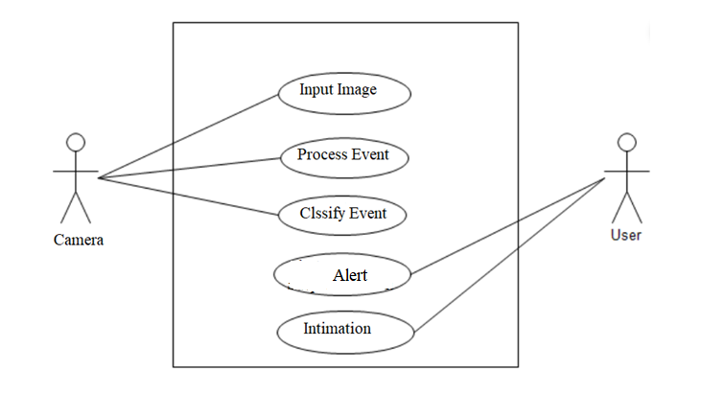

CHAPTER 5

IMPLEMENTATION

5.1 Modules implemented

Calculation for Automatic Number Plate Recognition System-utilizing OCR
- Read image from webcam.
- Alter image to dim scale.
- Identify number plate zone.
- Segmentation.
- Number distinguishing proof.
- Save to record in given arrangement.

Read Image from webcam.
- Capture image from webcam.
- Store up the caught image into a picture document for additional preparing.

Alter image to dim scale.
- Classify the power of the captured image.
In the event that picture power = high Reduce force Else if power = less
Increase power Else, No change.
- Convert picture into dim scale.
- Calculate suitable limit an incentive for the picture.
- Convert the picture into paired picture utilizing the determined limit.

Detecting Number plate zone
- Load tiny gaps including quantities of Number plate so number plate territory will be huge to seclude from figure.
- Determine width and tallness of the picture.
- Scan each and every pixel of line including number of white pixels in the accompanying framework. If number of white pixels is less that variable A then the pixels will become dark or else there will be no changes made and if number of white pixels greater than variable B then that pixels become dark or else there is no change. The estimation of A and B might be changed agreeing theimage force and plate zone.

- Use the progression no. 3 for both even and vertical heading.
- Check number of potential regions. On the off chance that number of zones greater than 1 Select appropriate region
- Logically AND operation with parallel picture got at "Convert picture into twofold" calculation.
- Crop the necessary zone.

Segmentation
- Channel the commotion level present in the picture.
- Clip the plate region so that lone quantities of plate territory removed.
- Separate each character from the plate.

Number distinguishing proof
- Create the layout record from the put away format pictures.
- Resize picture got from division to the size of format.
- Compare each character with the layouts.
- Store the best coordinated character.

Save to record in given arrangement.
  - Open a content record in compose mode.
  - Store the character acquired from the number distinguishing proof procedure to content document in given arrangement.
  - Close the document.
Use is the request of an application or execution of a course of action, thought, model, plan, unequivocal, standard, estimation, or structure. In that limit, Use is a declaration of a PC, programming or other PC process through programming and programming action.
There may be different executions for a given insurance or standard. Modules
    - Data Collection

    - Python OpenCV

    - Object Detection

    - Tensorflow

    - OCR

Modules description

Data Collection Smart Camera:
The sharp camera contains a twofold processor which empowers the camera to
work respectably with applications, for instance, plan planning, optical character insistence and information arrange code ceaselessly. The entire arrangement passes on critical norms lessen scale pictures which are fundamental for the execution of the industrious eye following estimation. Precisely when the smart camera is connected through FTP or Ethernet hard drive, the information would then have the choice to be moved to different gadgets.

Python OpenCV:

OpenCV is a library of PC vision delivered at first by Intel and now kept up by Willow Garage. It is protected to use under the permit of the open source BSD. It's a cross stage library. Generally, it bases on the readiness of the image. In the event that the library finds the framework's Integrated Performance Primitives, these business refreshed calendars will be utilized to speed it up. OpenCV isn't a bit of code that photos are running and preparing. You must compose content. The Visual Studio Express Edition of Microsoft can be downloaded (to no end). It's a remarkable IDE. The Visual C++ 2010 Express should be downloaded. Moreover, OpenCV isn't an executable document that you imitate and it will begin to work. It is code, library records, and DLL reports that are unadulterated. You "connect" to these library records when you compose your own code to get to the capacities of OpenCV.

Object Detection:
Article Detection is the route toward finding genuine thing events like vehicle, bike, TV, blossoms, and individuals in still pictures or Videos. It considers the affirmation, control, and acknowledgment of various things inside an image which gives us a significantly improved understanding of an image everything on the whole. It is generally utilized in machines, for example, picture recuperation, wellbeing, perception, and moved driver help structures (ADAS).
Article Detection should be conceivable by methods for different ways:

OCR:
- Detection of items dependent on their attributes
- Detection of items by viola Jones
- SVM HOG ID highlights

OCR (optical character affirmation) is the use of development to perceive printed

or interpreted substance characters inside cutting edge pictures of physical documents, for instance, a sifted paper record. The fundamental method of OCR incorporates dissecting the substance of a file and deciphering the characters into code that can be utilized to deal with data. OCR is from time to time furthermore implied as substance affirmation.
OCR structures are included a mix of hardware and programming that is used to change over physical records into machine-noticeable substance. Hardware, for instance, an optical scanner or specific circuit board is used to copy or get content while programming generally handles the pushed getting ready. Programming can in like manner abuse electronic thinking (AI) to realize additionally created procedures for keen character affirmation (ICR), like distinctive lingos or styles of handwriting.
The method of OCR is most routinely used to change printed adaptation authentic or important records into PDFs. At the point when placed in this sensitive copy, customers can change, arrangement and search the record as if it was made with a word processor.

Tensorflow:

Tensorflow is Google's Open Source Machine Learning Platform for programming information stream over a check of errands. Centers allude to numerical capacities, while the edges of the graph address the multi-dimensional purposes of data (tensors) inside them.
Tensors are basically multidimensional groups, a broaden to data with a higher estimation of 2-dimensional tables. Tensorflow's various features make it reasonable for significant learning. By consuming at whatever point, thusly, how would the decipher how can perform object discovery utilizing Tensorflow.
What is YOLO and for what reason is it Useful?

The R-CNN gathering of systems found in Part 1 in a general sense use locale to bind the articles inside the image. The framework doesn't look at the entire picture, exactly at the bits of the photos which have a higher chance of containing an article.

The YOLO structure (You Only Look Once) then again, supervises object affirmation in a substitute way. It takes the whole picture in a solitary case and predicts the skipping box masterminds and class probabilities for these holders. The best ideal situation of using YOLO is its famous speed – it's fabulously fast and can process 45 housings for each second. YOLO also understands summarized object depiction.
To prepare the model, as expected to gather a lot of pictures with the goal that this model can see how a bicycle looks. And yet, can't take care of a picture into the model and anticipate that it should distinguish the bicycle consequently. So should give some preparation parameters which will thus assist the model with finding the bicycle and see what it looks like. Then subsequently use the Open Images Dataset. The explanations behind utilizing this dataset are:
  - 15,851,536 boxes on 600 classes.

  - 59,919,574 picture level names on 19,957 classifications.

  - 478,000 publicly supported pictures with 6,000+ classes.

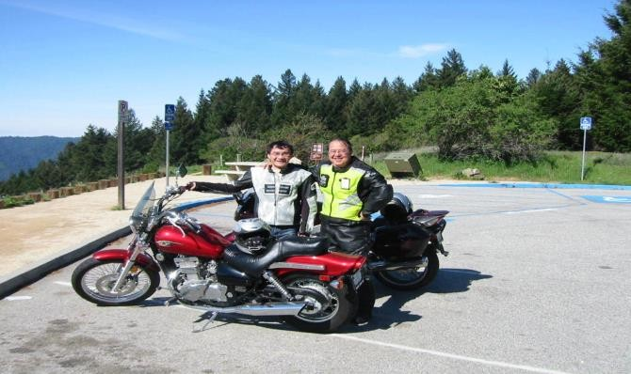To download the pictures that need, then utilize another program called Figure 7.1 OIDv4_ToolKit. This unit permits us to download just the documents required to prepare the model without downloading the entire dataset which is GBs in size. Presently the picture is spared alongside its mark to .csv(Comma Separated Values) documents are given – One to help the program with regards to where the container must be attracted and another to distinguish what it is.

Figure 7.1: Image of motor cycle and 2 person

Corresponding Label:

Motorcycle 113.999872 336.99993600000005 595.00032 683.000064

Motorcycle 366.999552 439.00032 728.999936 605.9996160000001

Libraries

- OpenCV(open source computer vision library)

Open source PC vision library and AI programming library .OpenCV is a cross-stage library utilizing which can grow constant PC vision applications. It chiefly centers around picture handling, video catch and examination including highlights like face identification and item location.
It can be used as:

import OpenCV as

>>pip install cv2

- Keras

Keras is an incredible simple to-utilize python library for creating and assessing profound learning models. It wraps the effective numerical calculation libraries theano and tensorflow and permits you to characterize and prepare neural system models in a couple of short lines of code.
The way it is used:

import Kereas as
>>pip install keras

Tensorflow
Tensorflo w is the essential programming device in profound learning. lt is an open source man-made consciousness library, utilized for information stream diagrams to manufacture models. Tensorflow is principally utilized for: discernment, arrangement, finding, getting, creation and forecast
The way it is used:
import Tensnrflow as
>>pip install tensnrflow

Imutils

Imutils are a progression of comfort capacities to make essential picture preparing capacities, for example, interpretation, turn, resizing, skeletonization, and showing

Matplotlib pictures simpler with OpenCV and both Python 2.7 and Python 3. The way it is used:
import Imutils as
>>pip install imutils

Pillow
Pillow is a Python 1maging Library (PIL), which includes support for opening or controlling or sparing pictures. The present adaptation Pillow recognizes and peruses an enormous number of configurations. Compose suppon are deliberately limited to t he most regularly utilized trade or introduction designs.
It can be used as follows:
import pillow as
>>pip install pillow

Twilio
By utilizing the Twilio application a product engineers can automatically make calls or get calls, send instant messages and get instant messages, and play out some correspondence capacities utilizing its web administration APls.
It can be used as:
import twilio as
>>pip install twilio

5.2 Algorithms

YOLO Algorithm
YOLO You Only Look Once (YOLO) was created to make a one stage process including location and grouping. Bouncing box and class expectations are made after one assessment of the information picture.
Certainty here alludes to the likelihood an article exists in each bouncing box and is characterized as: C = P r (Object) ∗ IOUtruth pred (1) where IOU, crossing point over association, speaks to a portion somewhere in the range of 0 and 1.
The class-explicit likelihood for every network cell is characterized as:

YOLO utilizes the accompanying condition underneath to figure misfortune and at last enhance certainty:

OCR Alogrithm

  - Image Acquisition: The initial step is to get pictures of paper archives with the assistance of optical scanners. Along these lines, a unique picture can be caught and put away. The greater part of the paper reports are highly contrasting, and an OCR scanner ought to have the option to limit pictures. At the end of the day, it ought to supplant every pixel in a picture with a dark or a white pixel. It is a strategy for picture division.
  - Preprocessing: The objective of preprocessing is to make crude information usable by PCs. The commotion level on a picture ought to be improved and regions outside the content evacuated. Preprocessing is particularly crucial for perceiving transcribed records that are increasingly touchy to clamor. Preprocessing permits acquiring a perfect character picture to yield better consequences of picture acknowledgment.
  - Segmentation: The procedure of division is planned for gathering characters into important pieces. There can be predefined classes for characters. Along these lines, pictures can be filtered for designs that coordinate the classes.
  - Feature Extraction
  - Training a Neural Network
  - Post-Processing

Convolutional Neural Network (CNN)
Convolutional neural framework is one of the principal categorie for the photos affirmation and pictures portrayals. Articles disclosures, affirmation faces, etc., are a bit of the regions where CNNs are commonly utilized. The Figure 7.2.1 shows the Neural Network with various convolutional layers. 1n certainty, the possibility of significant learning CNN models t can be used for train and attempted, every data picture will be adhered to the course of action of convulution layers with procedures (Kernals), Pooling, totally related layers (FC) by applying Softmax work can arrange an article with probabilistic characteristics runs some place in the scope of 0 and 1. The underneath figure is acomplete stream of CNN to process an information picture and requests the articles subject to values.

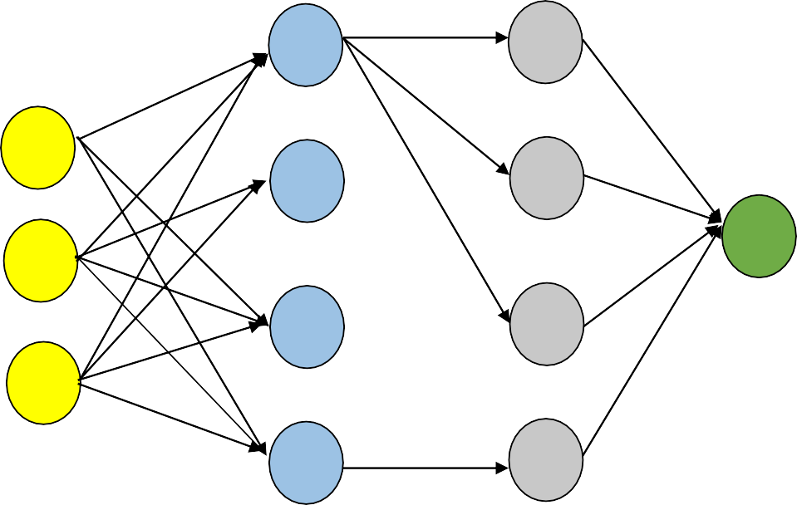
Input Layer
Hidden layer 1
Hidden Layer
Output

Figure 7.2: Neural Network with numerous convolutional layers.

Haar Casade
The Figure 7.3 shows the Haar Cascade Metres. Here will work with face area. Each classifier are attempted from the outset, for that it required a lot of positive (pictures faces) and negative (pictures without faces. At that print features should be removed from it. For this, Haar flights showed up in the underneath pictures are used. This look like a convolutional piece. Each segment is a singular worth obtained by deducting entire of pixels under the white square shape from entry of pixels under the dull square shape
(a) Edge Feature
(b) Line Feature
(c) Four-Rectangle Feature

Figure 7.3: Haar Cascade Features

The Figure 7.4 shows the Face Detection. For this, endeavor to apply each and every component on the readiness true . For every segment, it finds the best edge a motivations for requesting the appearances to positive and negative. By plainly, there will be goofs or misclassifications. Select each component with least screw up rate, which infers they are a couple of features that will be most definitely request the face and non-face pictures. (This methodology isn't as straight forward as t his. Each image are given a correspondingly weight at the start. For each gathering, a couple of heaps of misclassified pictures are extended. By then a comparable get will be done. New slip-up rates are resolved and new loads are moreover be resolved. The method is continued until the fundamental precision or bungle rate is practiced or the vital number of features are composed)

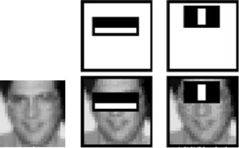

Chapter 6

Results & Discussions

CHAPTER 7

CONCLUSION AND FUTURE SCOPE

Conclusion
The proposed framework is a replacement to human traffic cop. The strategies for traffic observation have been introduced and the work on movement identification, tag extraction and character acknowledgment is done. The proposed framework catches the picture in rush hour gridlock signal extraction and character acknowledgment of tag will be considered during rule violation. Order of the traffic rule infringement will be done and the message will be send to the owners of the vehicle to illuminate them about the sort regarding rule abused and furthermore about the fine that must be paid.

Future Scope
The improvement of this model prompts the examination of new regions of robotization of traffic checking. The more precise component plan and increasingly hearty discovery strategy investigate will be executed in future. Shrewd bicycle can likewise be proposed which thus neglects to begin without wearing head protector and also that can stretch out the framework to discover the quantity of traffic wrongdoers in a region.

REFERENCES

    - K. Karthik & N. Pavithra & R. Nandini & C. Punyashree, “Automated Vehicle Driving using Image Processing”, international journal of computer science and engineering, volume-2, issue-4, april 2014.
    - R. Handaric. “An image recognition software tool for car identification based on license plate”, transylvania university of braşov series i: engineering sciences, volume-5 (54) no. 1, 2012.
    - Y. M. Prutha, S.G. Anuradha, “Morphological Image Processing Approach of Vehicle Detection for Real-Time Traffic Analysis”, international journal of engineering research & technology (IJERT) Volume 03, Issue 05, May 2014.
    - W.-L. Hsu, H.-Y., M. Liao, B.-S. Jeng and K.-C. Fan, "Real-time traffic parameter extraction using entropy", Proc. Inst. Elect. Eng.Vis. Image Signal Process., vol. 151, no. 3, pp. 194-202, Jun. 2004.
    - T. Yamashita, K. Izumi and K. Kurumatani, “Effective information sharing based on mass user support for reduction of traffic congestion”, The Proceedings of International Conference of Complex Systems, 2004.
    - M. Schnhof and D. Helbing, “Empirical features of congested traffic states and their implications for traffic modelling”, transportation science, vol. 41, pp. 135-166, May 2007.
    - J. Kong, Y. Zheng, Y. Lu and B. Zhang, "A novel background extraction and updating algorithm for vehicle detection and tracking", Proc. IEEE Int. Conf. Fuzz. Syst. Knowl. Discovery, pp. 464-468, 2007.
    - J. L. Wilder, A. Milenkovic and E. Jovanov, “Smart wireless vehicle detection system”, System Theory. 40th Southeastern Symposium, pp. 159- 163, March 2008.
    - O. Jahn, R. H. Mhring, A. S. Schulz and N. E. S. Moses, “System-optimal routing of traffic flows with user constraints in networks with congestion”, Operations Research. Vol. 55, August 2001.
    - K. Collins and G.-M. Muntean, "A vehicle route management solution enabled by wireless vehicular networks", INFOCOM Workshops IEEE, pp. 1-6, April 2008.

    - R. van Katwijk, P. van Koningsbruggen, B. D. Schutter and J. Hellen-doorn, "Test bed for multiagent control systems in road traffic management", Transportation Research Record: Journal of the Transportation Research Board, vol. 1910, pp. 108-115, January 2005.
    - J. Z. Hernandez, S. Ossowski and A. Garcia-Serrano, "Multiagent architectures for intelligent traffic management systems", Transportation Research Part C: Emerging Technologies, vol. 10, pp. 473-506, November 2002.
    - F.-Y. Wang, "Agent-based control for networked traffic management systems", IEEE Intelligent Systems, vol. 20, September 2005.
    - J. Z. Hernandez, S. Ossowski and A. Garcia-Serrano, "Multiagent architectures for intelligent traffic management systems", Transportation Research Part C: Emerging Technologies, vol. 10, pp. 473-506, November 2002.
    - “Y. Chen, B. Wu, H. Huang and C. Fan, "A Real-Time Vision System for Nighttime Vehicle Detection and Traffic Surveillance," in IEEE Transactions on Industrial Electronics, vol. 58, no. 5, pp. 2030-2044, May 2011.
    - A. Kircher, M. Uddman and J. Sandin, Vehicle control and drowsiness, 2002.
    - R. Yustiawati et al., "Analyzing Of Different Features Using Haar Cascade Classifier," 2018 International Conference on Electrical Engineering and Computer Science (ICECOS), Pangkal Pinang, 2018
    - C. Liu, Y. Tao, J. Liang, K. Li and Y. Chen, "Object Detection Based on YOLO Network," 2018 IEEE 4th Information Technology and Mechatronics Engineering Conference (ITOEC), Chongqing, China, 2018
    - Z. Lu, J. Lu, Q. Ge and T. Zhan, "Multi-object Detection Method based on YOLO and ResNet Hybrid Networks," 2019 IEEE 4th International Conference on Advanced Robotics and Mechatronics (ICARM), Toyonaka,
Japan, 2019
    - N. Jmour, S. Zayen and A. Abdelkrim, "Convolutional neural networks for image classification," 2018 International Conference on Advanced Systems and Electric Technologies (IC_ASET), Hammamet, 2018.
    - Z. Li, X. Zhu, L. Wang and P. Guo, "Image Classification Using Convolutional Neural Networks and Kernel Extreme Learning Machines,"

2018 25th IEEE International Conference on Image Processing (ICIP), Athens, 2018.
    - T. Guo, J. Dong, H. Li and Y. Gao, "Simple convolutional neural network on image classification," 2017 IEEE 2nd International Conference on Big Data Analysis (ICBDA), Beijing, 2017.
    - R. van Katwijk, P. van Koningsbruggen, B. D. Schutter and J. Hellen-doorn, "Test bed for multiagent control systems in road traffic management", Transportation Research Record: Journal of the Transportation Research Board, vol. 1910, pp. 108-115, January 2009.

